Missing Files

Brandon Potter

03/18/17

# Missing ACH and/or REMIT Files

At 14:00 and 16:30 everyday, an ACH and REMIT file is created and sent to HPE.

## Involved Servers

* D1PP
* BCBSAIX1
* MP-ABS-SA0*

## Alerts

At either 14:00 or 16:30, you may see an email alert with the subject: *!! PRODUCTION ACH File not found* or *!! PRODUCTION REMIT File not found*. This means the scheduled tasks on D1PP failed and need to be re-queued. See [Figure 1](ACH%20missing.png) and Figure 2 for screenshots.

## Steps

1. Login to D1PP with either vSphere or RDP.
   * If you use RDP, be sure to set the domain as *DOC1*.
   * D1PP is located in FlexPod 7.
2. Stop JBOSS. On the Desktop is a shortcut, *Stop JBoss Services*.
3. Start JBoss. Shortcut on Desktop, *Start JBoss Services*.
4. From your computer, go to <http://d1pp.doc1.bcbsaz.com:8912/clientweb>.
5. Login with appropriate account based on environment. Username is *operations*, password is located in *G:\Ops\Shifts\Logins.xlsx*.
6. Start all the internal agents.
   1. Under **Operations** on the sidebar, click **Available Agents**.
   2. Click **Start All Available Agents** at the bottom.
7. Resubmit the task.
   1. Under **Operations** on the sidebar, click **Scheduled Tasks**.
   2. Click **Add Task**.
   3. Click **SchedInLT** for **BCBSAZ_ACH_DELIVERY_SET**.
   4. Fill in the details using the table below.
   5. Watch the job for the next 30-40 minutes to ensure it suceeds.

Details for job.

|  |  |
| --- | --- |
| Field | Value |
| Name | ACH Scheduled Task |
| Scheduled Date | Same day, 1 minute later |
| Payment Type | Bank_Debit |
| Delivery Output Folder | D:\e2\bcbsaz_data\payment |
| Delivery Format XML Path | D:/e2/format_xml/ACH_Payment_Delivery.xml |
| Remittance Output Folder | D:\e2\bcbsaz_data\payment |
| Remittance Format XMLPath | D:/e2/format_xml/ACH_Payment_Remittance.xml |
| Subscriber Output Folder | D:\e2\bcbsaz_data\payment |
| Subscriber Format XMLPath | D:/e2/format_xml/ACH_Payment_Subscriber.xml |

## Figures

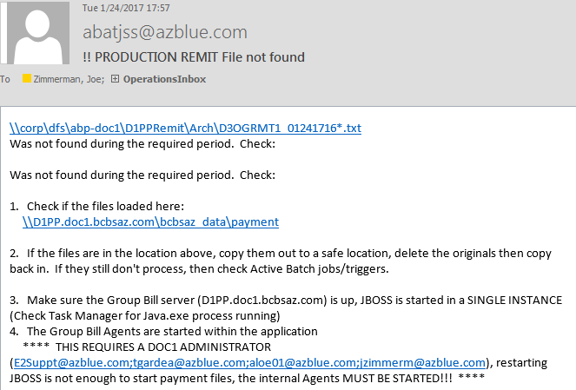

Figure

Missing REMIT email.

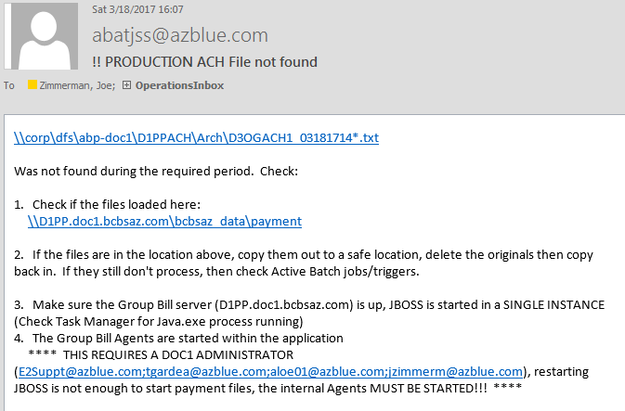

Figure

Missing ACH email.